UTA 100 2017

The Beauty of Planning

I’ve visualised this exact moment for almost a year…sitting, with my laptop, looking back over the amazing race I’ve just taken part in and writing it up. Everything, from the initial slow runs in November through to the long trail runs in April…the nutrition planning, the pain management, the shoe/sock combination…the whole smash. The only thing I didn’t visualise was the first sentence.

UTA 100 is one of life’s bookmarks for me…what has become, for the past five years, an annual event, whether I’ve run it or not (and I’ve been on the start line four out of the five). It has changed the way I look at running, and at life…I still remember the first time I checked in to UTA race registration (although back then it was called The North Face 100), surrounded by a pack of exceptionally fast looking athletes, none of which had even the slightest hint of body fat. I was so intimidated that I had to leave the room…it wasn’t until Dimi calmed me down that I was able to join the group at the prerace dinner, feeling quite ill with anxiety.

And my first ultramarathon, eight months prior to that (an Oxfam Trailwalker 100), was completed on sheer will power, with the shortest race plan in history:

1. Take nutrition every hour, on the hour.

My nutrition, as an aside, was pikelet sandwiches filled with peanut butter and honey (as opposed to the carefully measured caloric intake I have today). There’s a great shot of me at the 35k point, trotting along with Sebastian Warmerdam, in walking shorts with a full school sized backpack (I’ve still got scars from the chaffing of that combination). I’m smiling, having a great time in the photo, unaware of the hell which awaited me in the darkness around 80k or the two weeks of recovery in the future.

This year, however, was different…this was the first year that I truly felt the right to be on the start line. I’d done the distance, written the plan, and taken control of as much of the puzzle as possible. This was, in many respects, my first ultramarathon.

But enough ruminations…let’s talk about the day.

Last year, I skipped the race briefing…just ran in for the quick registration and then headed back to my accommodation, barely hanging out at the Festival of Runners. This year, I came up early and soaked in the atmosphere. It was raining and there was a blanket of fog over the cliff tops as I walked down to the top of Furber Steps to watch the tail end of the 22k runners come up the trail. Mud was everywhere and I could see the effort they’d put in during their relatively short sprint.

Walking around the Festival and the start/finish line, I kept running into people whom I’d met either at previous races or on the trail…it’s a small family and we’re all connected by friends and kilometres. A hot bowl of freshly made chilli con carne took the chill out of the air as I made my way to the race briefing and the fog hugged the ground like a blanket.

Of all the notes to self I’ve made over the years, this one is most important: ALWAYS go to the race briefings and prerace activities. Not just for the information, but for the gee-up and inclusion. Seeing the aboriginal elders welcome us to their lands, hearing Tom’s obligatory bad jokes, feeling the vibe of the room…it’s all part of the tradition…the process of prerace.

It was also where my race plan was thrown into chaos: rain had forced a major course change and the closure of Checkpoint 3. Even worse, a significant amount of rain was forecast overnight, meaning that an already wet course was going to deteriorate into a mud run by the time I came through. And while the course change traded elevation and nice wide firetrails (mostly runnable) for single track cliff top scrambles, it looked like it would be slower – and I hadn’t trained on it. More stairs, less overall climb.

Of all the notes to self I’ve made over the years, this one is most important: NEVER let something you can’t change effect you. I started to freak out slightly, trying to visualise the changes, calculating times, splits, climb effort…and it all got too much. Just let it go.

WARNING – there are technical bits up ahead! If you’re not interested in the science, the theory, the nuts and bolts of this crazy adventure, you might want to just skip ahead to the closing bit where there’s a really fun bit about me kicking ass during the closing section of the race. Really upbeat and not at all technical.

Still with me? Ooooh….hardcore! Read on.

Back at Chez Gunny (my accommodation for the last two years of UTA racing), I laid out my race gear, loaded my check point gear and went over my race plan. Again. I was running, this year, for a sub 19 hour finish and had been doing everything based not on how my body felt at the moment, but on how my time per kilometre was tracking. I figured if I could maintain an average of 9:36 per kilometre over 100k, I’d cross in 16 hours.

“9:36,” I hear you say? “Nine minutes and thirty-six bloody seconds?!? Per kilometre? I walk my dog faster than that!”

True. You probably do. But not over vertical terrain (this year had an estimated 5k of vertical climb). And stairs. And single track along cliff edges. So, I decided to shoot the average…a maximum flat run of 7 minutes/k. Now, on a road surface, I can lay down a consistent 5:30 over 10k or 5:00 over 5k. But I’m toast afterwards and require a Berroca, a relax with a good book and a nice stiff martini. On road, I can hold a 6:00/k pretty much indefinitely, but that’s not trail. And doesn’t offer much in the way of margin…so, a 7:00/k is conservative and will allow me to recover easily.

Doing the math…each light downhill section, run at 7:00 minutes, gives me an extra two minutes and thirty-six seconds to grind out a kilometre of uphill, stairs, gnarly bits or bandaging snake bites. Or so the theory goes. Reality and theory aren’t good friends, normally, and are rarely seen in the same company.

The reality is far harsher…sections of Golden Stairs, Nellies Glen and Furber can take up to 20 minutes per kilometre, depending on track condition, time of day and nutrition. And other sections of downhill…the Giant Stairs, that endless cliff around Gordon Falls and Leura Cascades…are all in the 13:00/k area; you can only go down makeshift stairs so fast. And in the dark, no one would find the body if you went over the cliff.

Fun sport, this Ultra Trail stuff.

Bottom line, 9:36/k is an aggressive time for me. My previous best was around 11:40/k across the whole course. But it was a plan. I knew I couldn’t hold it, and was only using it as a guide to ensure I could get across under 19:00.

Saturday morning’s alarm went off at 5:15, and, as usual, I woke at 5:13, minutes before. Quick shower, a banana for breakfast, and a light shudder as I realised I was still hearing rain on the roof. Continuing my race prep checklist, I started pulling on my running gear with an extra slathering of anti-chaff lube. Racing skins, socks, shoes, lucky red top and matching red pack (I swear I’m the most colour-coordinated straight guy on the course) and I was ready for the drive to the start line.

On the walk to the car, I was struck by how warm it was. Fog was thick, rain was falling and it reminded me of that special muffled feeling that I used to hear as a child during heavy snowstorms. In the car, I was struck by how hard it was to see anything. 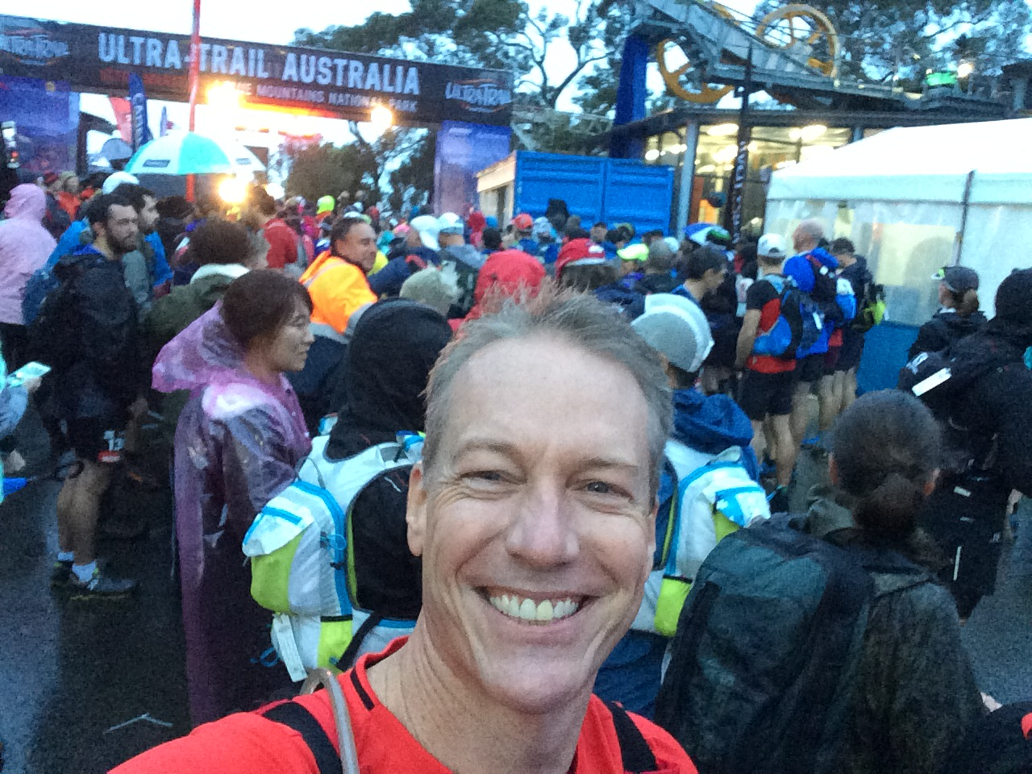During the quick 15 minute drive up to the race, I was fortunately not struck by anything. Giving the keys to Gunny, I gave him a quick hug and jumped out for the walk to the start line.

On The Start Line

Rain spattered on the pavement like hot oil in a wok. The pre-dawn light was almost completely extinguished by the fog, and it wasn’t until I was almost on top of the start line that I realised that there were hundreds of people lining the streets and crowding the area. As I approached, I saw the first wave of the 100k blow past their 5k mark at pace, the crowd cheering and cowbells ringing. The chill I felt at that point had nothing to do with the air temperature…I was about to put my body through another 100k challenge.

Timing was perfect as I’d gotten out of the car with a mere ten minutes to spare before my 6:57 am start…hardly enough time to build nerves, just enough time to check my pack straps, set my race timer and work my way to the front of the pack for a selfie with Tom. 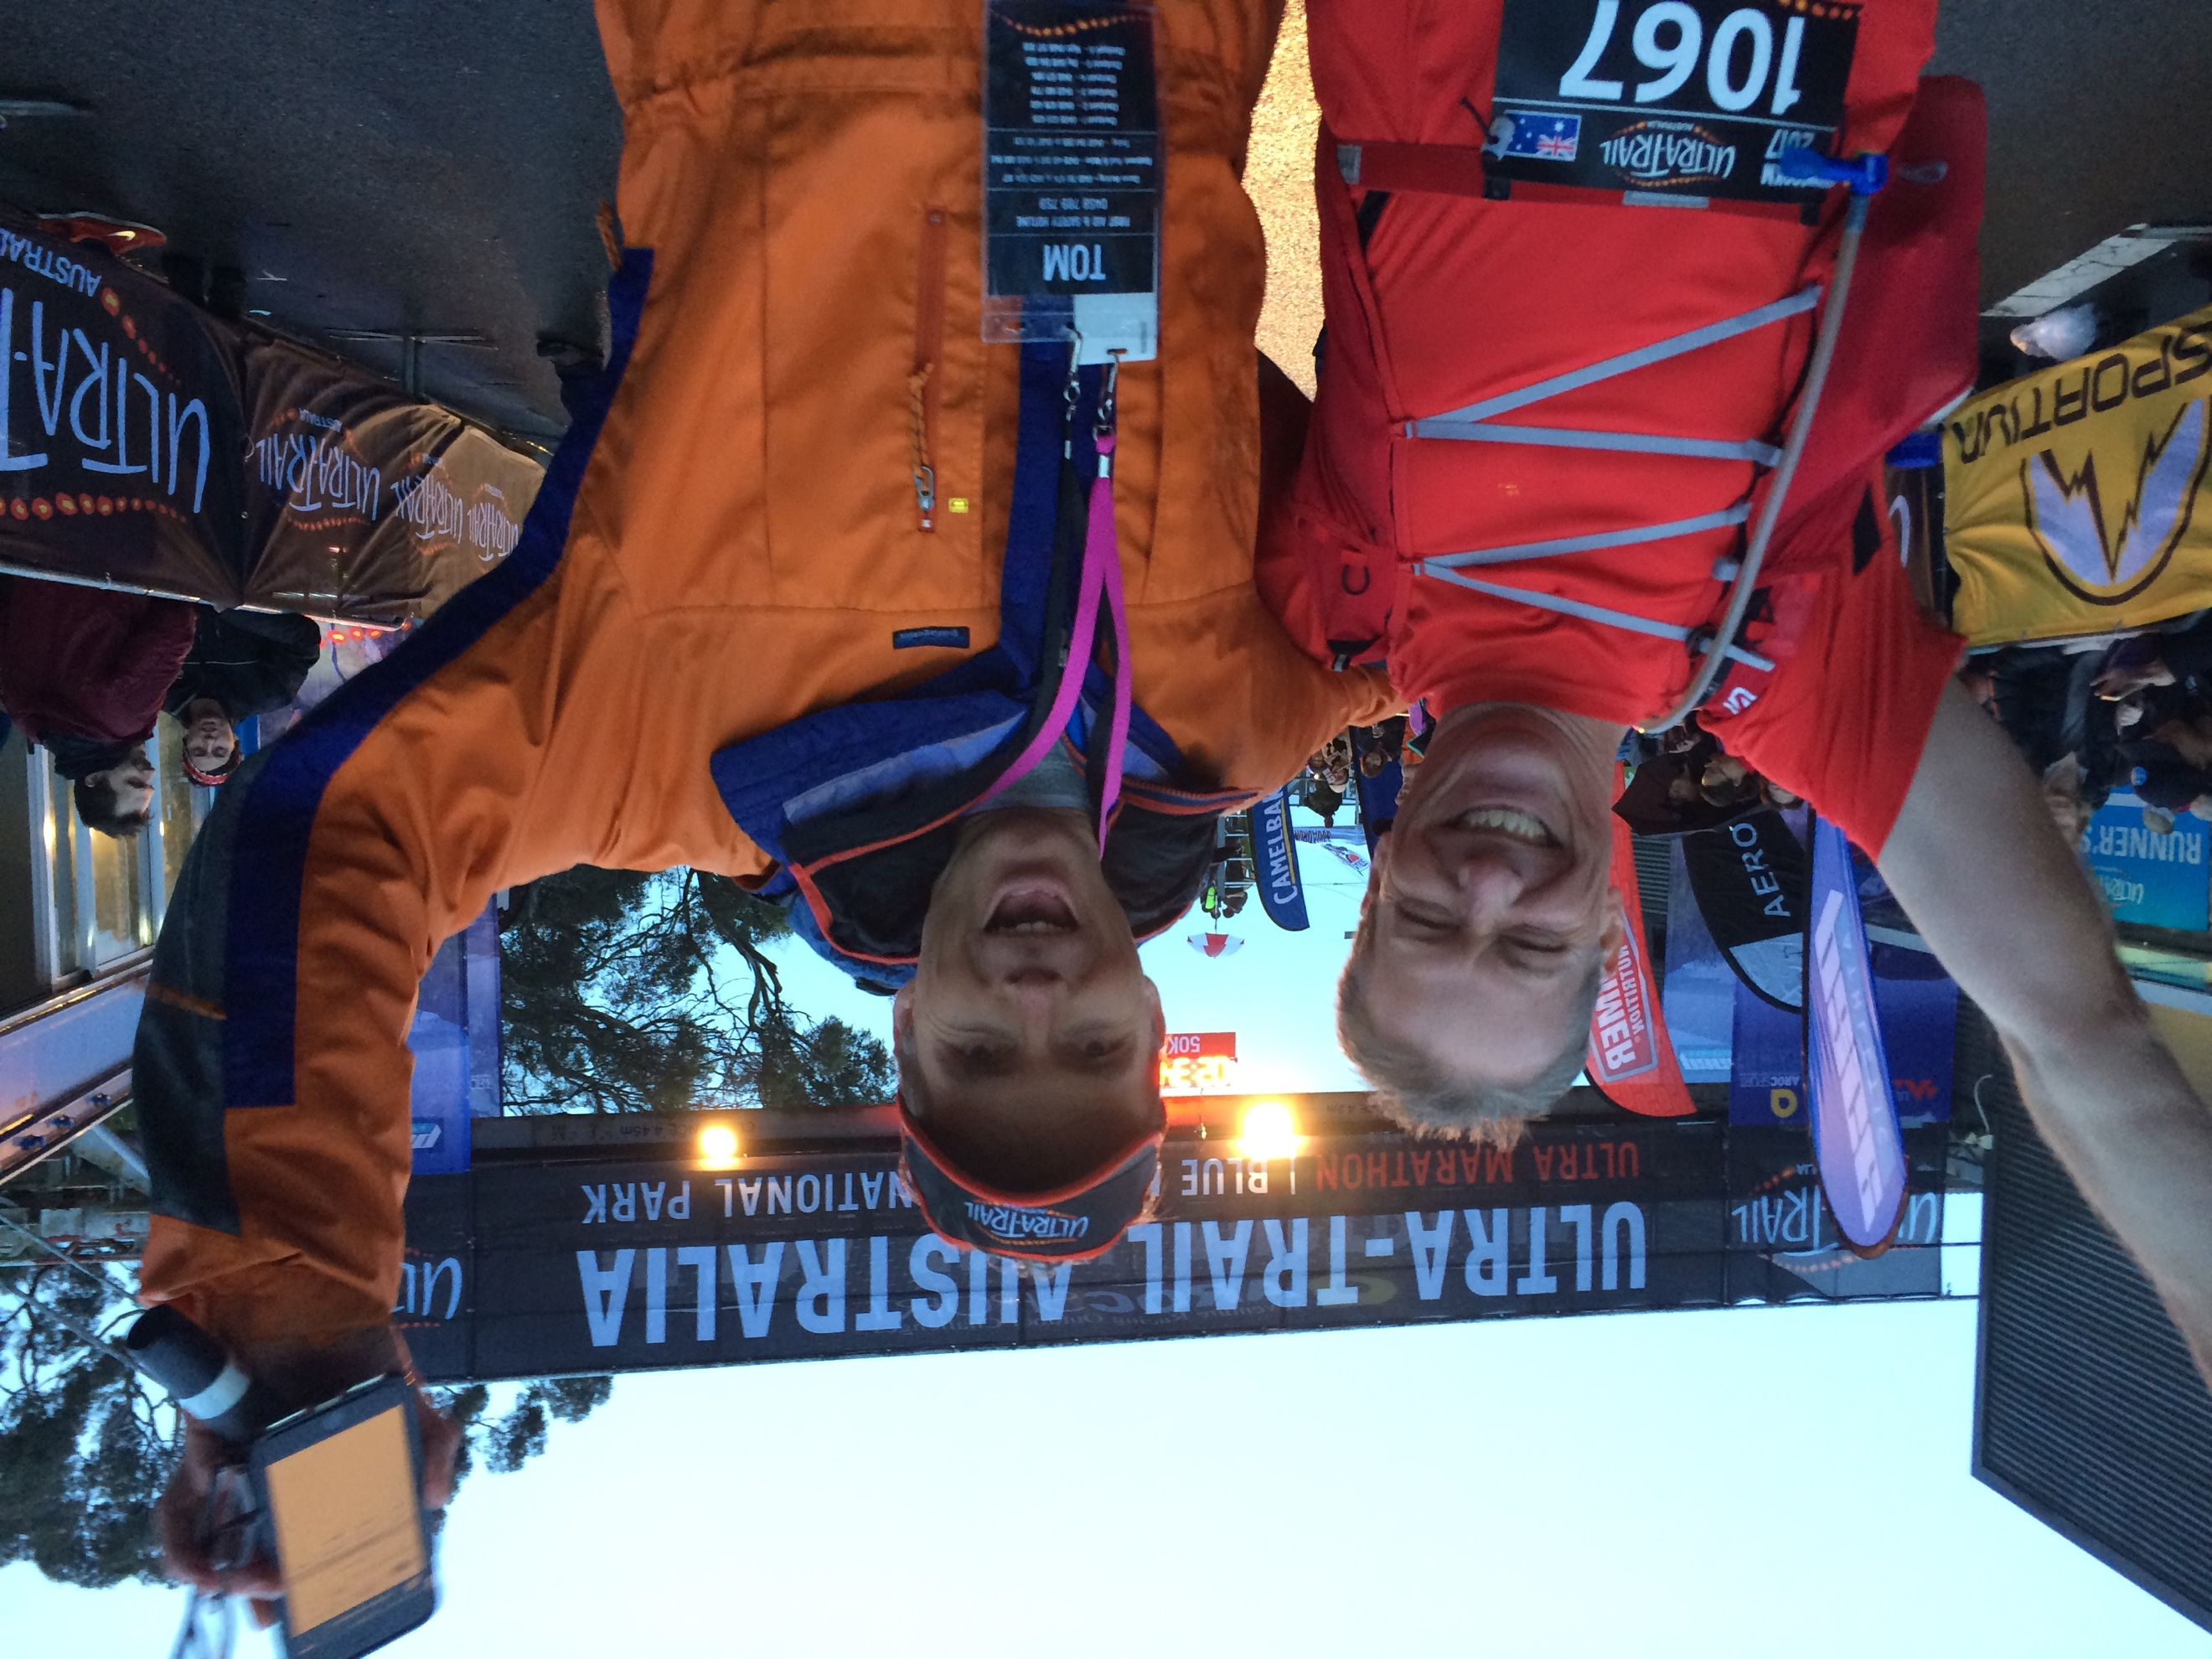I ran into Allison Lilley, one of my running Sensei, along with a handful of friends from both the Trotters and previous races. Looking backward across my start group, I see plenty of deer in the headlight looks, newbies wondering how this will unfold. My job here is simple…keep the emotions completely in check and slow down.

Tom Landon Smith...it's his fault

Tom begins to whip up the crowd as the 30 second mark comes and goes…one last slow blink of the eyes, internal check of my breath, pulse and race checklist….the obligatory countdown from 10 and boom…

It’s amazing to me, the boundary conditions of life…like jumping into a swimming pool: one second your dry and comfortable, the next you’re immersed in cold water and wondering why you didn’t stay dry and comfortable in the first place. For me, one moment I was quietly minding my own business, standing in the rain with 219 other oddly dressed people…a moment later, I’m running through the mountains in rain and fog.

The first 4k are always a bit of a bun fight as the newbies jockey for position and burn off all of their early race energy….2k of uphill road, a turning point, and then 2k right back down to pass the start before heading off road to single file track and Furber Steps. I stayed out of the main fray of bodies, fast walking the hill and letting my Achilles come to life; Allison was alongside me and we slowly transitioned from walk to trot, watching the steady stream of runners come the other direction back down the hill after the turn. I saw Lance Beament, Billy Bridle and a pile of other friends…. all running smooth and relatively fast. I consciously ignored my ego, which was telling me to run and catch up with them.

Of all the notes to self I’ve made over the years, this one is most important: STICK TO YOUR RACE PLAN.

As we came around the turn at the top and began running downhill to recross the startline and plunge into the bush, Strava went off, saying that I was at 7:45/k…pretty much spot on for what I was trying to do. Allison backed it up a few minutes later, saying that I was going out nice and slow.

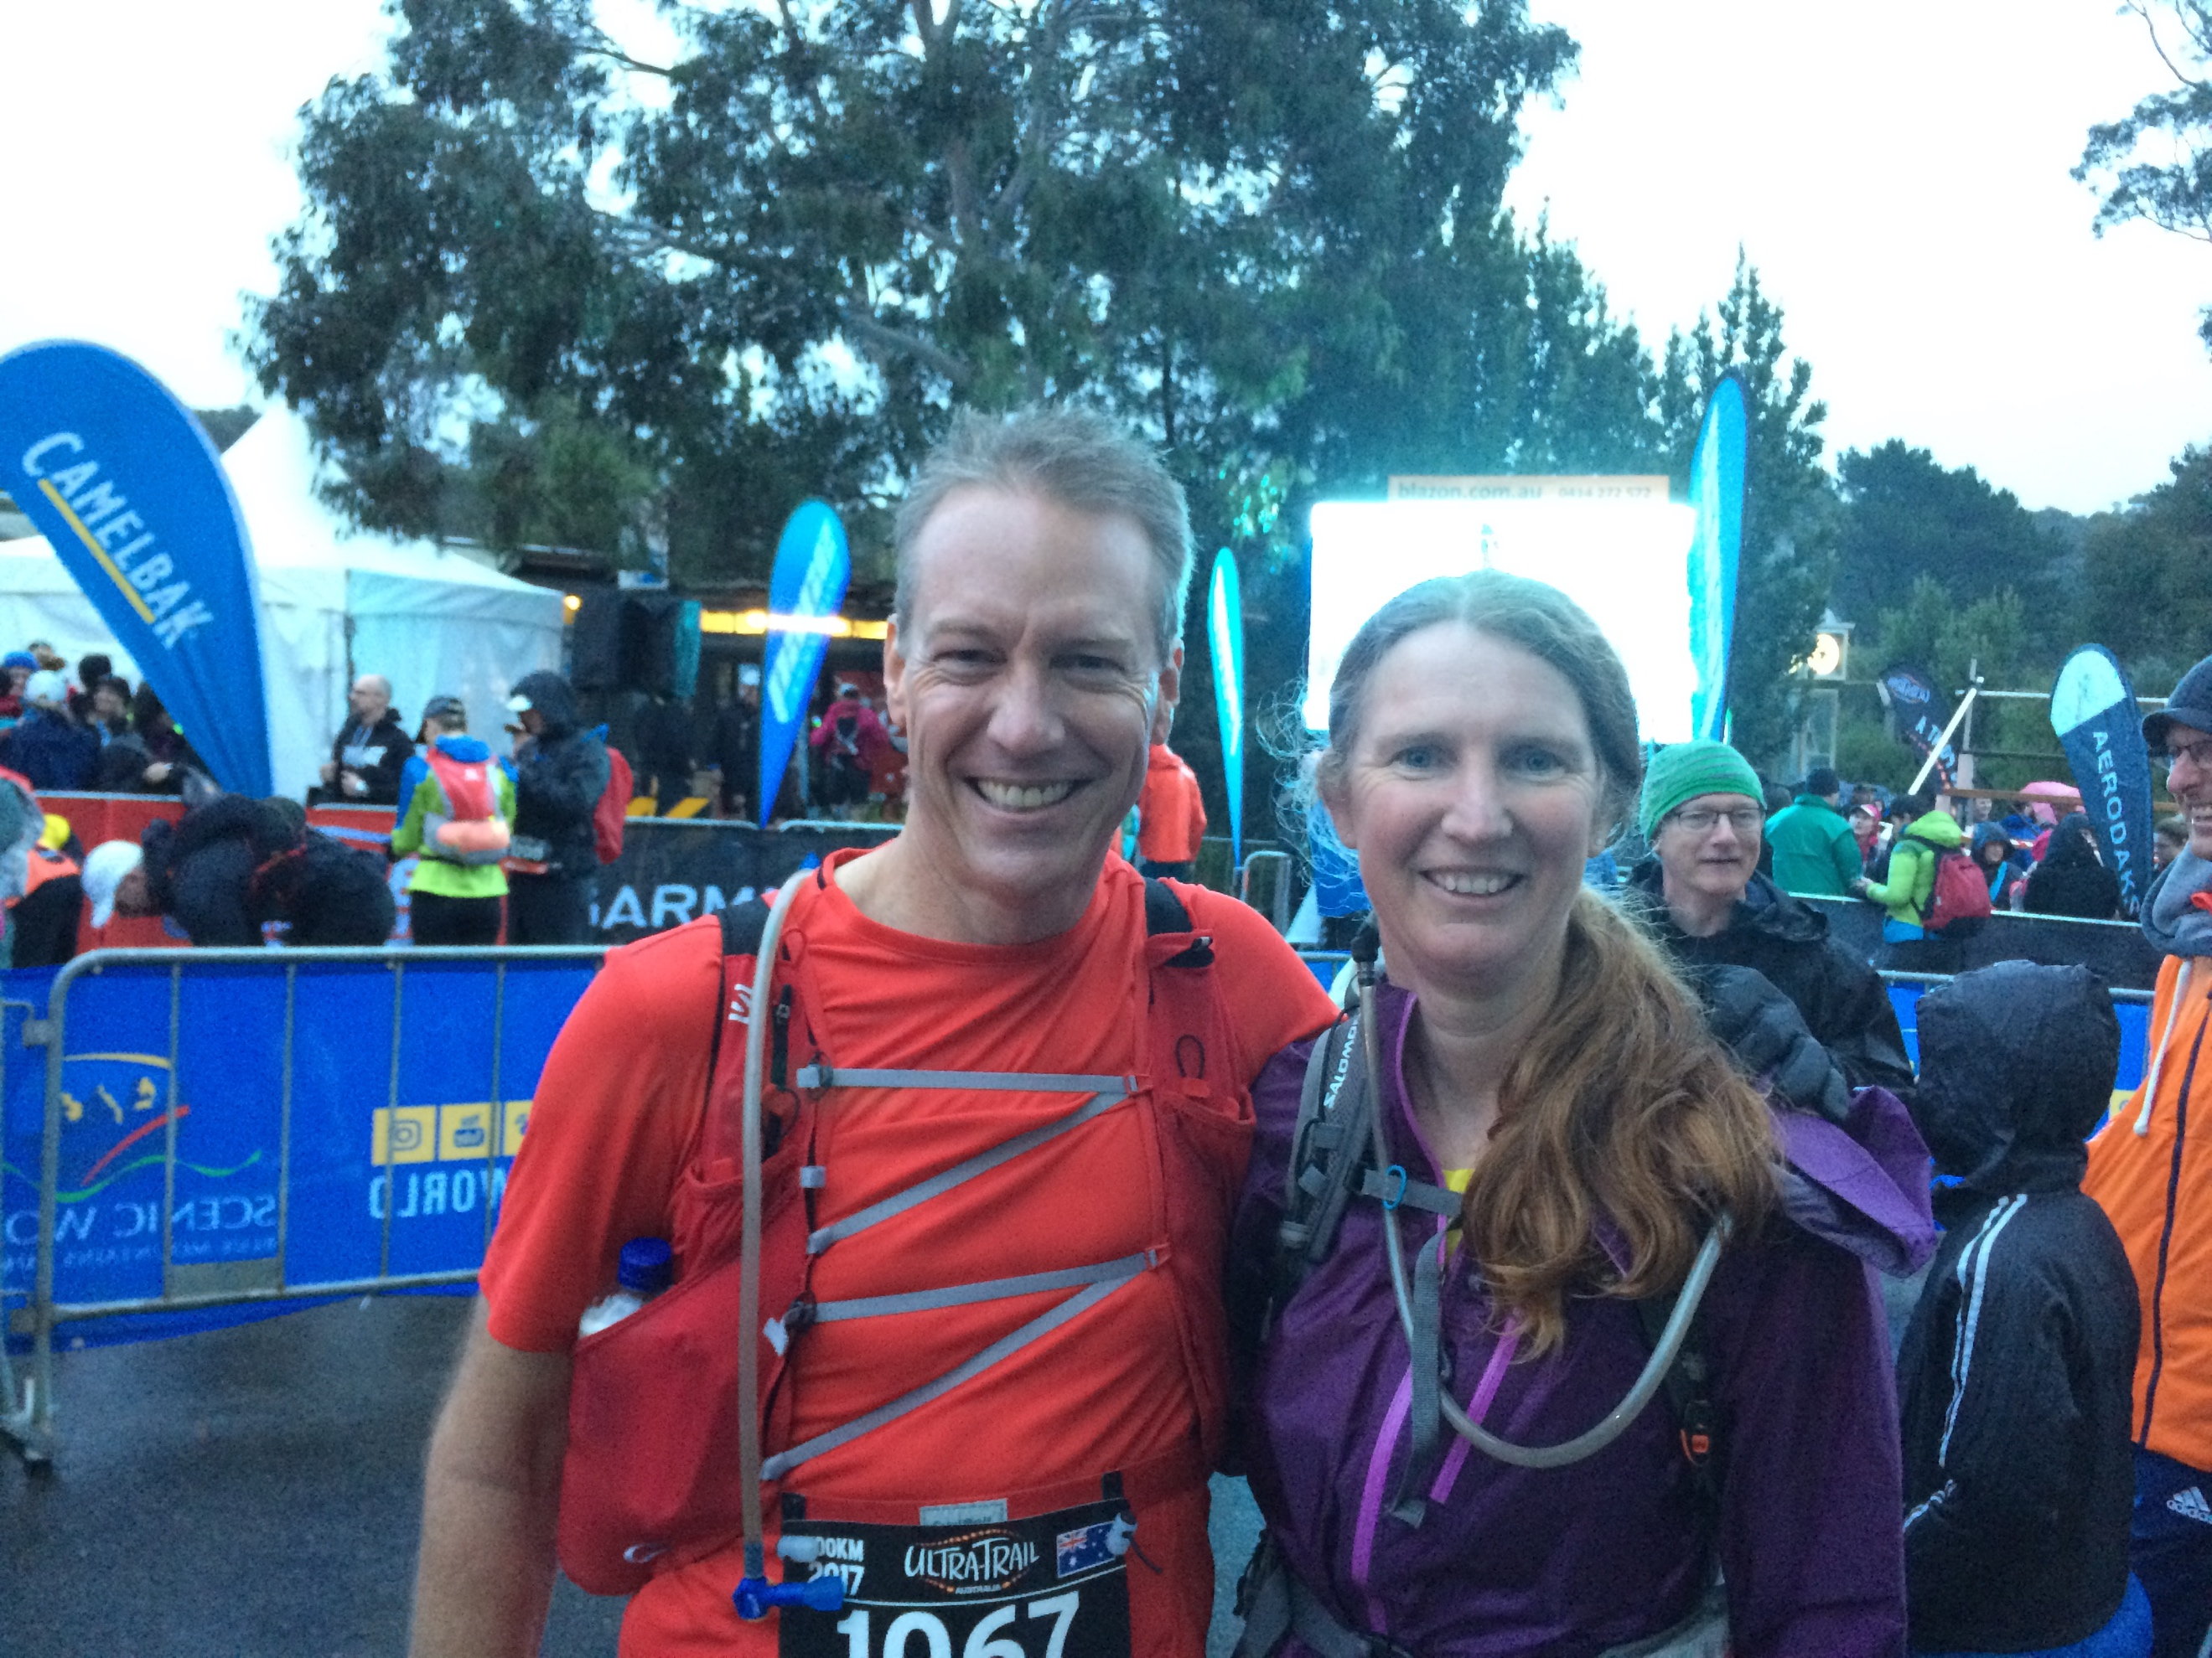

Allison Lilley, Pace Master Extraordinaire

Past the start line at the 4k mark, we got one last chance to run through the crowd; kids lined the streets with raised hands for High-Fives, cowbells ringing…even a morning breakfast table set up in someone’s yard – the two couples were having champagne and toasting the runners as we came by.

5k…into the bush, and down the stairs. Conversation was lively as we splashed through the first puddles; no point in trying to keep the feet dry as the course was filthy. I kept everything in check, through the down, across the landslide and then up Golden Stairs.

The Golden Stairs…the first real climb of the day. Single file conga line, no real place to pass, and my first point of seeing how I felt going straight up. The field around me was gasping and slow, but I was fine; sure, a tough climb, but nowhere near the effort from last year.

Of all the notes to self I’ve made over the years, this one is most important: Race training pays off.

I got to the top of Golden and hit the last kilometre into Checkpoint 1, literally running through without pause, out onto Narrow Neck. Somewhere during the next 10k, I found myself running with a group that I’d spend most of the day with…Brian, William, Phillip, Perri, Anthony…Brian was the most consistently paced runner, matching me almost stride for stride.

34k in (Checkpoint 2), as I was getting a small hotspot taped up, I sat next to a very fresh looking runner named Louisa – she had twisted an ankle, but didn’t look nearly in enough pain to pull out. A few words together and she ran out of the checkpoint with me. 20 minutes later, I ran past Ness, a young lady from Dubbo whom I’d met on a training run climbing up Kedumba a few months earlier…she tagged on the back and gamely hung on.

I’m not going to walk through the entire course…people have done that many times over and, quite honestly, I don’t want to drag anyone through it; but for the rest of the day, until sunset and well past, this small core of people shared my trail and made my race.

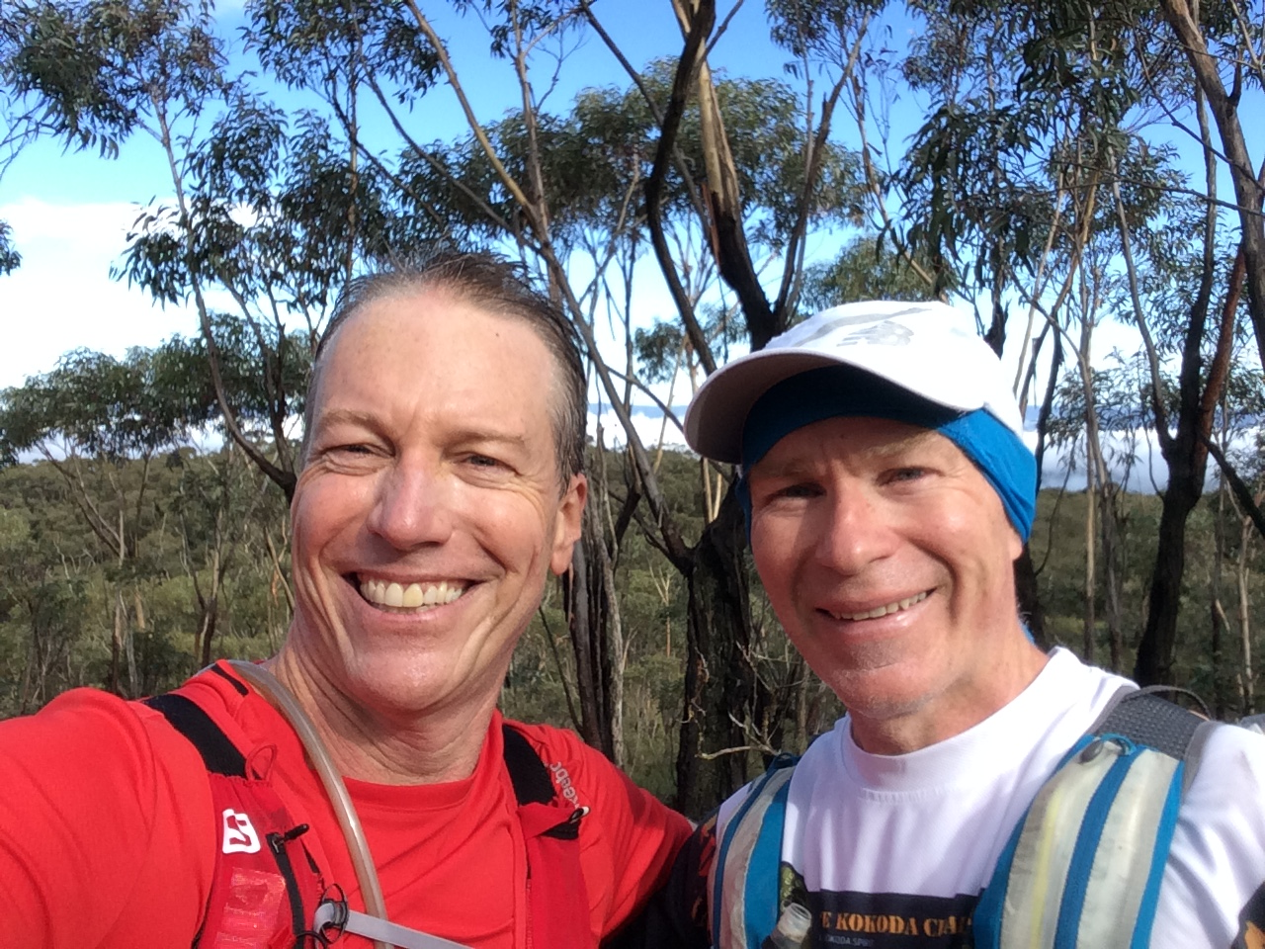

Approx 20k in: Brian Swan, 100 Miler and General All Around Nice Guy

Climbing out of Nellies Glenn, I started to put some distance between myself and the group. My climb felt great, and I wanted to get into and out of Checkpoint 4 before 4:30 in the afternoon. Checkpoint 4…Graham and Cara appeared, carrying my support bag. Six minutes later (according to the timing chip), I was back out the door with fresh shoes on my feet and the best tasting noodles in my hand. Still, I kept to my slow pace, listening to Strava tick off the half kilometres; 8:00/k, 7:45/k…a few in the 11 minute area where the track was tougher. And as night fell, the times crept up a bit.

But something weird was happening…I wasn’t slowing my pace…it was already relatively slow. My breath was well under control, my emotions in check. But I was starting to pass people. Not quickly, but consistently. Listening to the people around me, I could hear complaints of ITB, fatigue, flattened energy…

Something else happened on that leg to Checkpoint 5: I ran alone for a half hour or so, completely in my own space. No other runners, no other lights. The sky was completely clear and washed fresh from the rain. The moon had set long ago and the stars were as clear as I’d seen them in many years. I watched Venus rise and saw the International Space Station orbit past it. I was running…with 70k in my legs…and felt completely at peace.

I will run this race for as many years as I can for the chance to experience those 30 minutes again.

Coming down the hill into Checkpoint 5, it was around 8:00 pm and a light bit of fog had developed around the warmth of the Checkpoint. They had a DJ kicking out tunes and as I came across the line, I kicked a bit of speed and danced my way through…just because I had the extra energy and felt so good. Love the crowd.

In the Checkpoint proper, Graham and Nick were there waiting for me. My stomach had pretty much shut down to the thought of anything solid and I was still carrying a Cliff bar from the very start of the race. We filled my water bladder with Maximus, a sugar laden sports drink and I emptied my shoes of sand, sitting still for just a second. As I was sitting there, in my own little quiet, contemplating the last 20k, Nick leaned in and said, “Ok…you’ve held back all day. You’re still relatively fresh and you look great. Now’s the time to let it all go. Time to get to work.”

That’s all it took. A few simple words, and all of the training that I’ve done kicked in.

If you’ve skipped ahead from the earlier technical discussion, this is the point to start reading from, where I get to kick some serious trail ass. I came out of the checkpoint with a cup of hot noodles in my hands, working my way back up Tablelands Road…on the way, I was passed by Dimity and Cara in Graham’s car, Dimi leaning out the window screaming, “go Dougie!” Even more gee-up.

Coming up the hill at a walk/trot, I passed my first two people…I’d seen their headlights and safety vests in front of me and just ran them down. As I passed, I saw my next target a couple of hundred metres in front…and kicked it in to catch them. Into Rocket Point, down Wentworth, across to Conservation Hut…I kept seeing people in front of me and putting them behind me. Coming up to the corner of the Fairmont, I saw two guys death marching through a crowd who were cheering them on…I kicked into a sprint and danced around them, absolutely revelling in the crowd response.

Through Gordon Falls, down Leura Cascades…bombing along at a pace I’d barely manage during the day with fresh legs…and then in Federal Pass, with a mere 3k to go, I caught up with a long train of runners on a single file section. Quick tap on the shoulder of the person at the back and I jumped over them, like a sheepdog through the flock. The final slow climb up Furber was hell, like every other time I’ve drudged it out. But no worse than normal and no headspins…and, more importantly, a real incentive to get it done. As I reached the halfway point, I saw the lights of Scenic World hanging over my head…at two thirds, I could hear the crowd as they welcomed runners across the line.

As you come into the final little climb of Furber, visibility opens to a couple of hundred metres in front of you. Normally, just a patch of bush where the T intersection is, tonight it is marked with a dozen spectators, each pushing me on:

“Come on, Doug….push it,” and “you’ve got this…this is the end of the climb.”

At the T intersection, hard left turn and scramble up a few steps onto the board walk…every time I’ve done this in the past, I’ve barely been able to lift my feet. Tonight, it’s different – I’m leaning in, running, actually ACCELERATING up the boardwalk to the main pavilion area of Scenic World.

“And coming in fast, we’ve got Doug Boyd…he DNF’d last year, but is looking strong at the end now,” I hear the race announcer call as the finish line comes into view. I lengthen my stride, quicken my pace and LEAN into it, pushing, relishing the last drop of energy as it leaves my tank, hitting the finish line in a full on sprint.

Just like that, the boundary is broken. I’ve jumped back out of the water. My race is finished and I’ve left the course behind me, carrying with me an experience which will last a lifetime. Oh…and race bling…a beautiful bronze buckle for a sub 20 hour finish, a nice shirt and a UTA towel.

Twenty minutes later, the towel is suitably damp after my shower and I’m sitting at the table with Dimi, Graham, Nick and Cara…elated and dazed that the run is over and remarkably fresh. I’ve finished in a personal best time and completely without injury.

What an amazing event. An amazing day. And an amazing training season. I executed my race plan to the tee and completed pretty much where I thought I would, without pain or injury. I am so incredibly blessed to have the support of such wonderful people in my life…Dimity, my folks, my fellow runners, my work community…and equally blessed to have a body which seems to not mind this sort of abuse. I acknowledge my blessings and thank any and all who have been on this journey.

Finally, I close as I often do…with an invitation. Come join me. On the trail. On the road. At an airfield or in a workshop. Anywhere but in front of a television. I’m going to do this for years to come, having already signed up for a marathon this coming weekend and Mt. Solitary the weekend after. Come out, see the stars, feel the cool breeze and taste the morning.

The Statistics

Start Time: May 20th, 06:57

Duration: 17:48:10 (previous personal best 100k of 19:24:07, in 2013)

Distance (as per Strava…glitch prone as it is): 106.4 km

Vertical Climb (again, as per Strava): 6.14 km

Calorie Burn: 13,533

Calorie Intake (estimated): 8 slices watermelon, 1 cliff bar, 2 litres Maximus, 240 calories Hammer Perpetuem, 4 Hammer bars, 2 cups of hot noodles

Supplements: 2 NoDoz tablets